**Experiment No: 1(A)**

**Name:** Prem S. Kharat

**Roll No:** 4102

**Title:** Google Colab Implementation Steps

Step 1: Open Browser and type Google colab and open first link.

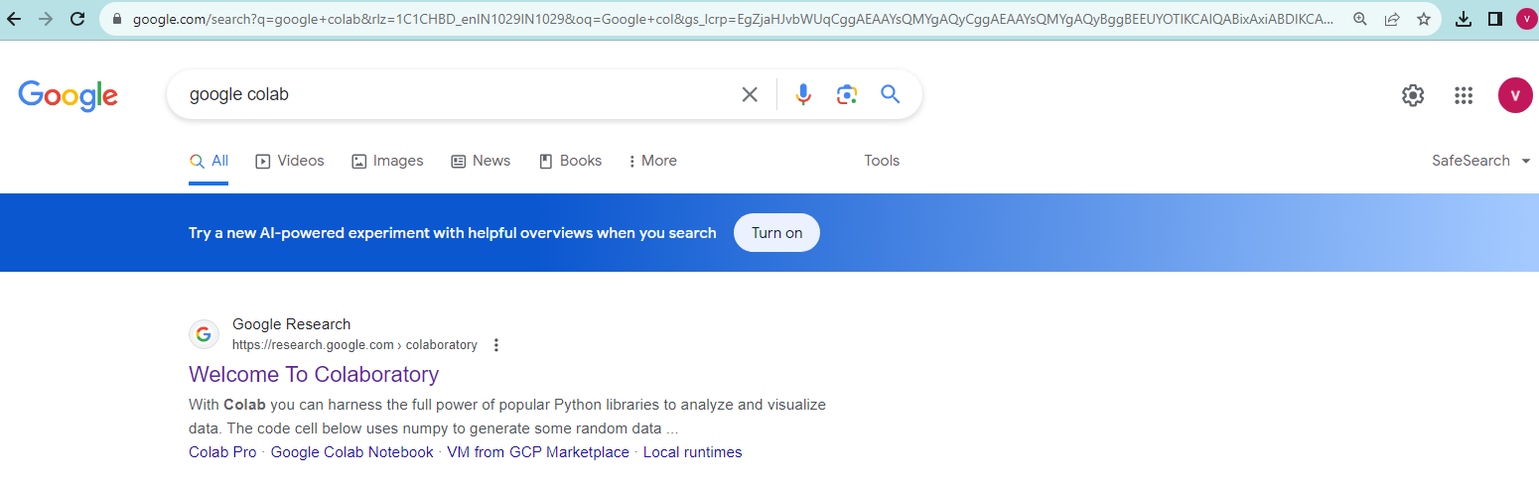

Step 2: In this link there is an option new notebook click on open notebook.

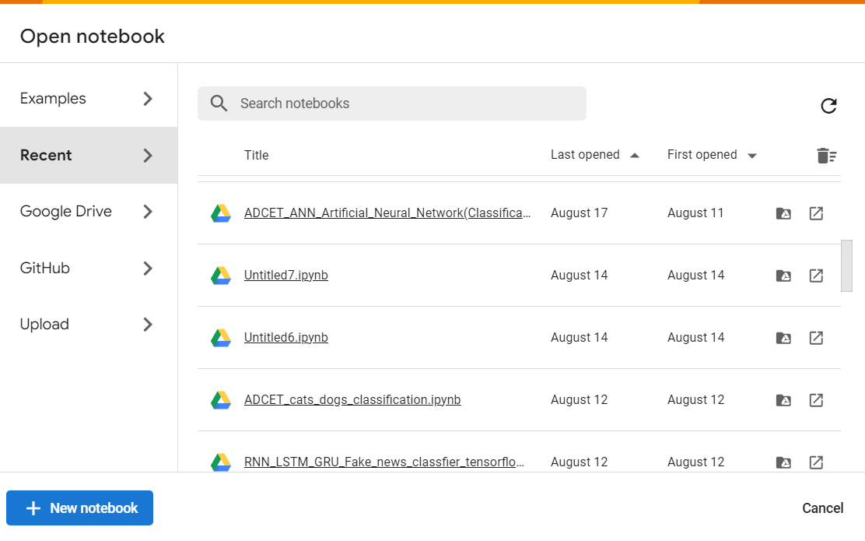

Step 3: It will open the interface to write a python code.

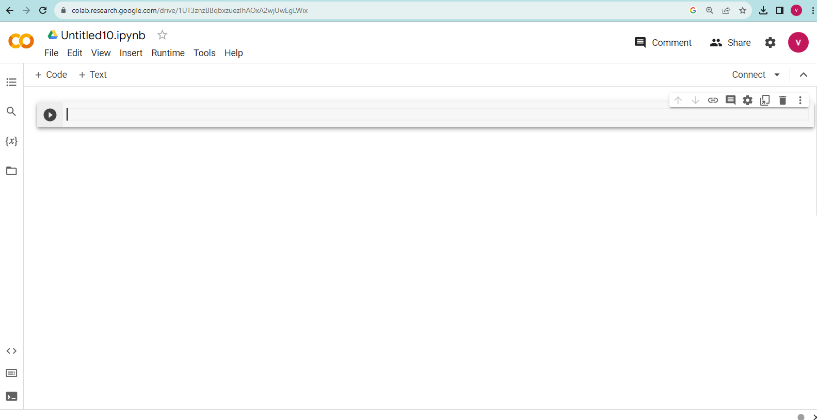

**Experiment No: 1(B)**

**Title:** Take Dataset Analyze and Classify it.

**Code:**

#Importing necessary Libraries

import numpy as np

import pandas as pd

import tensorflow as tf

import matplotlib.pyplot as plt

#Loading Dataset

data = pd.read_csv("/content/drive/MyDrive/Churn_Modelling.csv")

data

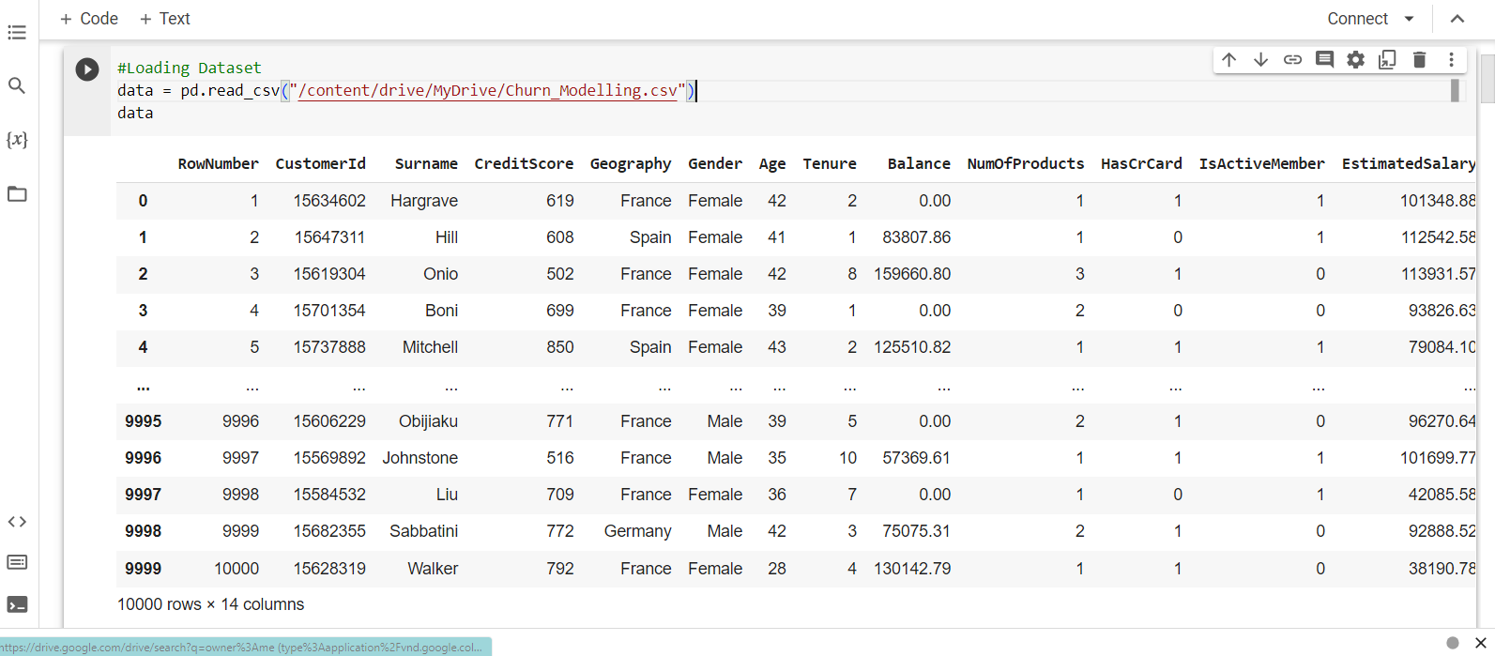

X = data.iloc[:,3:-1]

print(X)

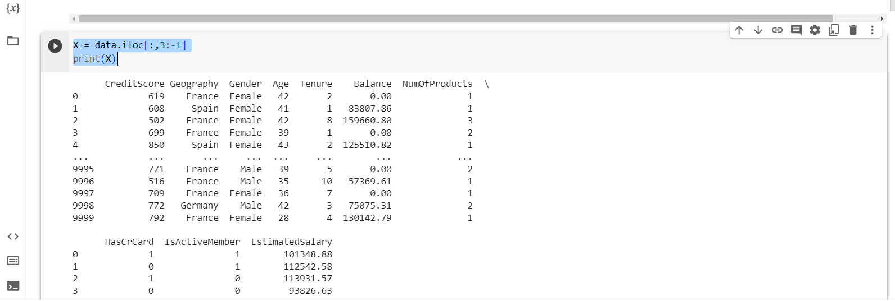

#Generating Dependent Variable Vectors

Y = data.iloc[:,-1]

Y

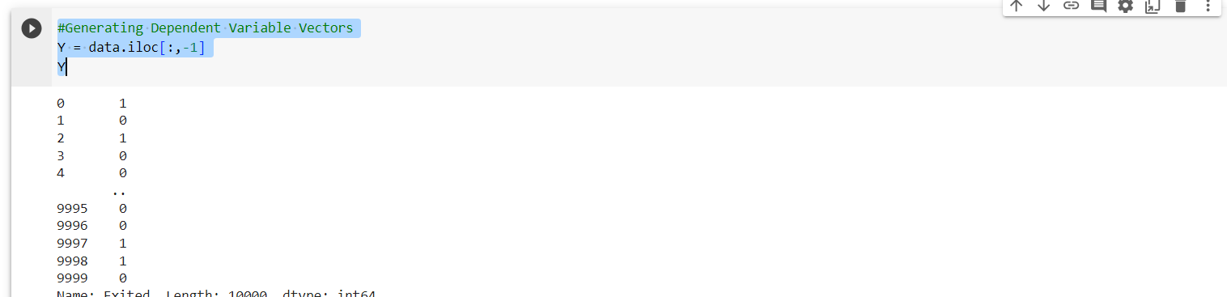

#Create dummy variables

geography=pd.get_dummies(X["Geography"],drop_first=True)

gender=pd.get_dummies(X['Gender'],drop_first=True)

## Concatenate the Data Frames

X=pd.concat([X,geography,gender],axis=1)

## Drop Unnecessary columns

X=X.drop(['Geography','Gender'],axis=1)

# Splitting the dataset into the Training set and Test set

from sklearn.model_selection import train_test_split

X_train, X_test, y_train, y_test = train_test_split(X, Y, test_size = 0.2, random_state = 0)

X_train

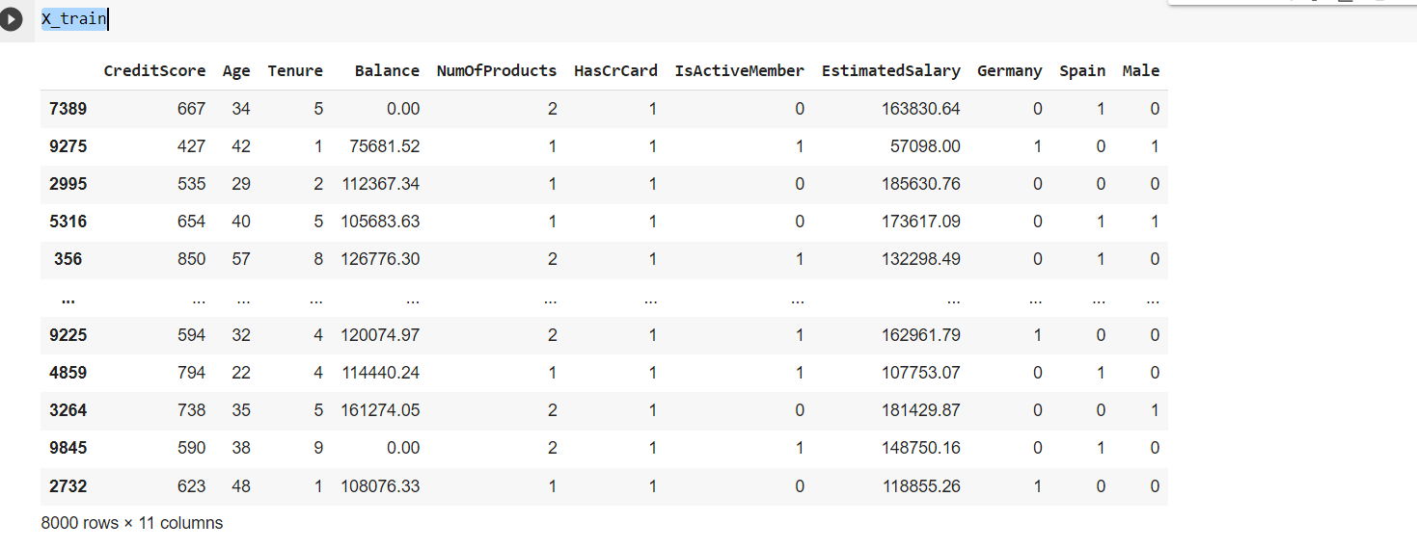

X_test

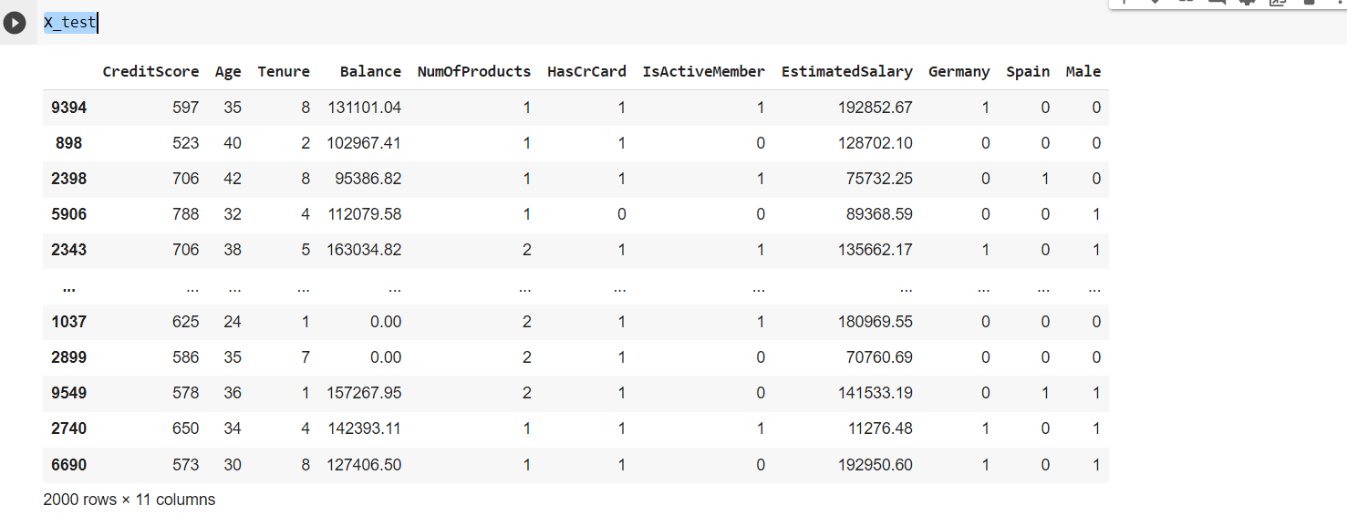

# Feature Scaling

from sklearn.preprocessing import StandardScaler

sc = StandardScaler()

X_train = sc.fit_transform(X_train)

X_test = sc.transform(X_test)

from sklearn.linear_model import LogisticRegression

LR=LogisticRegression()

LR

LR.fit(X_train,y_train)

y_pred=LR.predict(X_test)

y_pred

LR.score(X_train,y_train)*100

LR.score(X_test,y_test)*100

# Importing the Keras libraries and packages

import keras

from keras.models import Sequential

from keras.layers import Dense

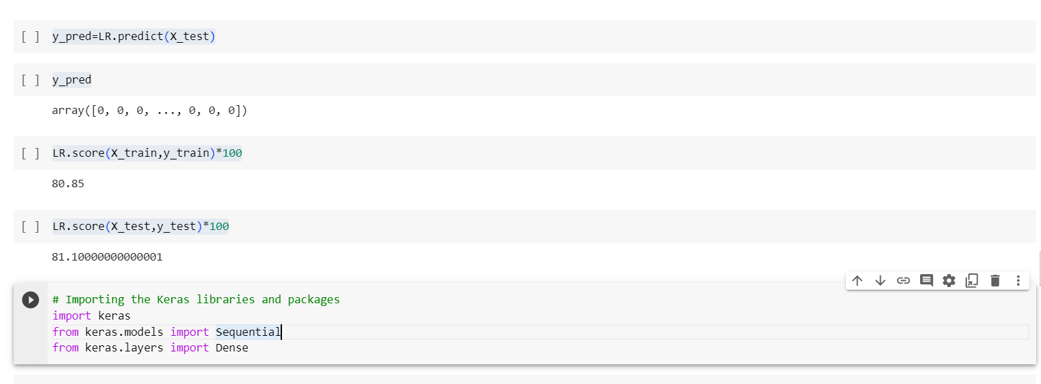

# Initialising the ANN

classifier = Sequential()

# Adding the input layer and the first hidden layer

#Initializers define the way to set the initial random weights of Keras layers.

classifier.add(Dense(units = 6, kernel_initializer = 'he_uniform',activation='relu',input_dim = 11))

# Adding the second hidden layer

classifier.add(Dense(units = 6, kernel_initializer = 'he_uniform',activation='relu'))

# Adding the output layer

classifier.add(Dense(units= 1, kernel_initializer = 'glorot_uniform', activation = 'sigmoid'))

# Compiling the ANN

#Computes the cross-entropy loss between true labels and predicted labels.

#Use this cross-entropy loss for binary (0 or 1) classification applications.

#Calculates how often predictions equal labels.

classifier.compile(optimizer = 'Adam', loss = 'binary_crossentropy', metrics = ['accuracy'])

model_history=classifier.fit(X_train, y_train,validation_split=0.33, batch_size = 10, epochs = 100)

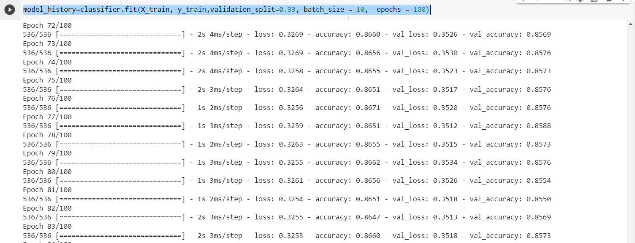

classifier.summary()

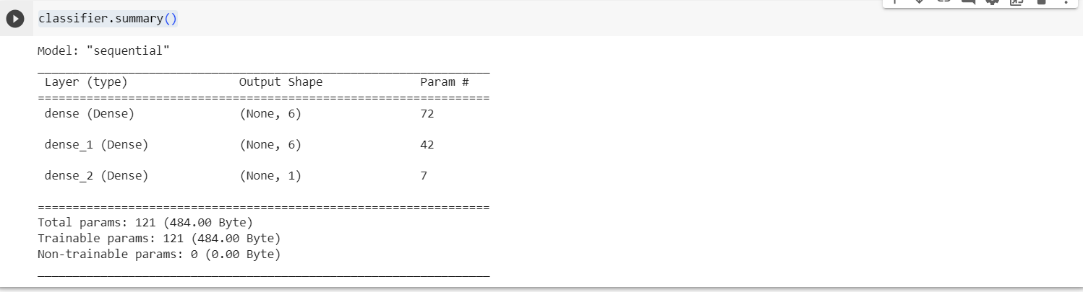

# Predicting the Test set results

y_pred = classifier.predict(X_test)

y_pred

y_pred = classifier.predict(X_test)

y_pred = (y_pred > 0.3)

y_pred

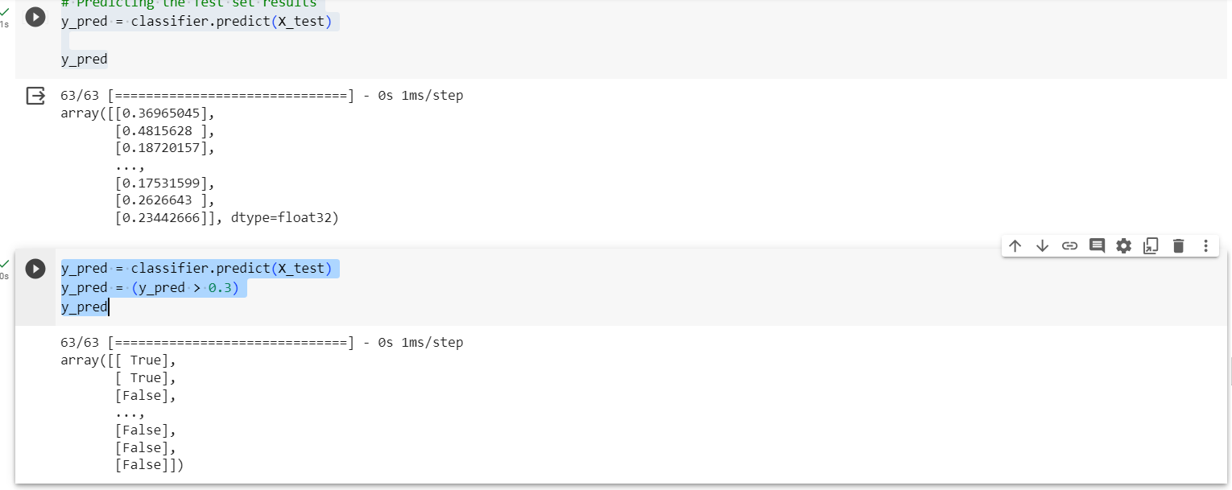

#credit score,age,tenure,balance, num products,hascard,is active member,estimated salary,germany,spain,male

output=classifier.predict(sc.transform([[650, 30, 2, 500000, 1, 1, 1, 100000, 0, 0, 1]]))

output

[1 if y > 0.3 else 0 for y in output]

output=classifier.predict(sc.transform([[120, 35, 2, 0, 1, 1, 1, 100, 0, 0, 1]]))

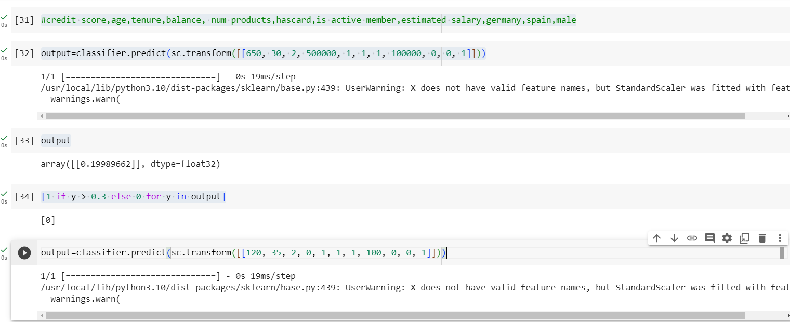

output

[1 if y > 0.3 else 0 for y in output]

# Calculate the Accuracy

from sklearn.metrics import accuracy_score

score=accuracy_score(y_pred,y_test)

score

print(model_history.history.keys())

# summarize history for accuracy

plt.plot(model_history.history['accuracy'])

plt.plot(model_history.history['val_accuracy'])

plt.title('model accuracy')

plt.ylabel('accuracy')

plt.xlabel('epoch')

plt.legend(['train', 'test'], loc='upper left')

plt.show()

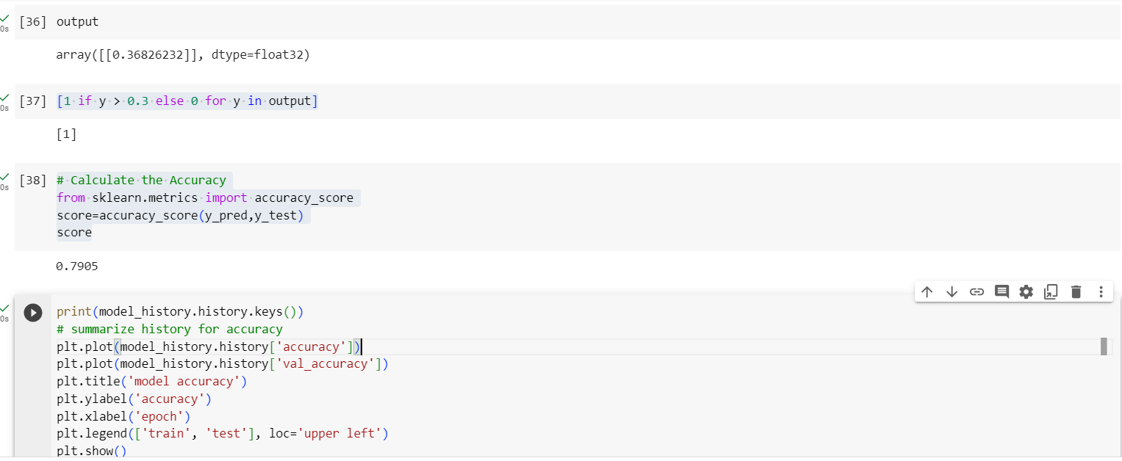

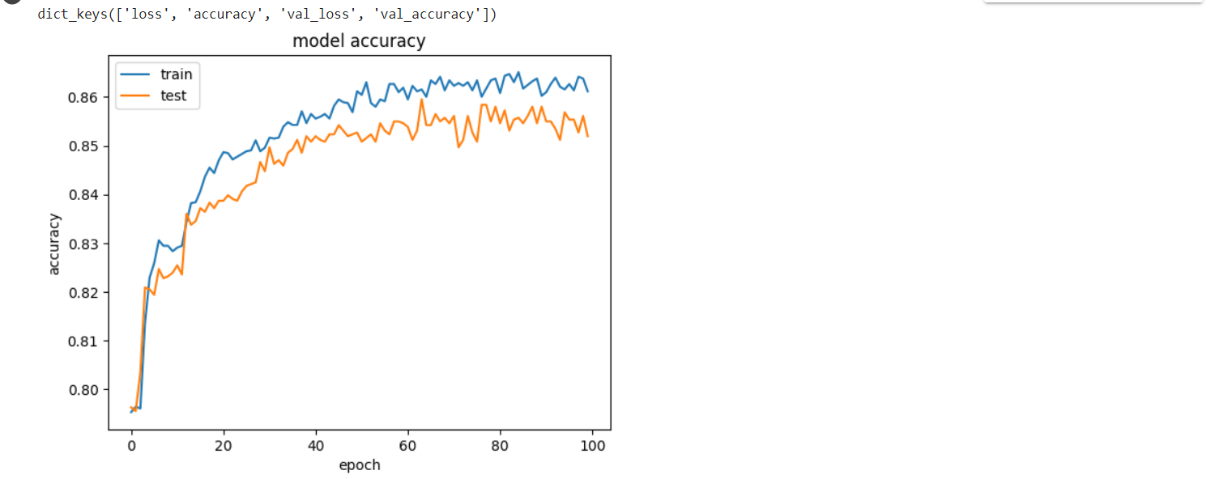

# summarize history for loss

plt.plot(model_history.history['loss'])

plt.plot(model_history.history['val_loss'])

plt.title('model loss')

plt.ylabel('loss')

plt.xlabel('epoch')

plt.legend(['train', 'test'], loc='upper left')

plt.show()

